**Semester Project: MT-1003**

**Calculus and Analytical Geometry**

**Section: BS CS (G)**

***“Practical Usage of Differentiation and Optimization in Real Life: Water Tank”***

**Contributors:**

**22i-1239 Tauha Imran**

**22i-1339 Hamza Ahmed**

**22i-0827 Muhammad Ali**

|  |  |  |
| --- | --- | --- |
| No. | Content | Starting Page |
| 1 | **Objectives and Introduction** | **2** |
| 2 | **Flowchart** | **3** |
| 3 | **Analytical Solution** | **4** |
| 4 | **MATLAB Code** | **8** |
| 5 | **MATLAB Solutions and Results** | **9** |
| 6 | **Conclusions** | **11** |
| 7 | **Contribution** | **11** |

**Objectives and Introduction:**

According to the statement provided, the dimensions and prices of water tanks are to be found for a housing society. Having chosen a cubic shape, we firstly, must calculate the dimensions for a 10,000-gallon water tank. Secondly, after we have the dimensions, cost is to be calculated. In it, we include the restrictions of a minimum of 6 inches of thickness on each side and a square mesh of steel bars with a spacing between 6 inches to 9 inches. This cost has to be tested to see if it is the minimum possible cost. If not, what it? Thirdly, MATLAB programs have to be generated for the following:

1. Optimal dimensions for a specific volume
2. Total cost for tank with specific dimensions
3. Finding costs for ten different dimensions

Thus, the objective of the process above is to find the optimized value for the dimensions of the water tank to come up with the minimum cost for performing the task of providing the housing society with water tanks.

**Flowchart:**

Following is the flowchart showing the flow of ideas and order of processes used to come up with the final solution:

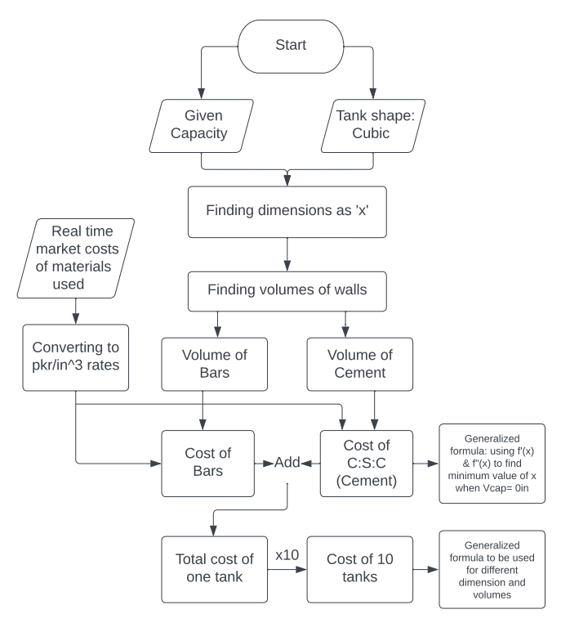

**Analytical Solution:**

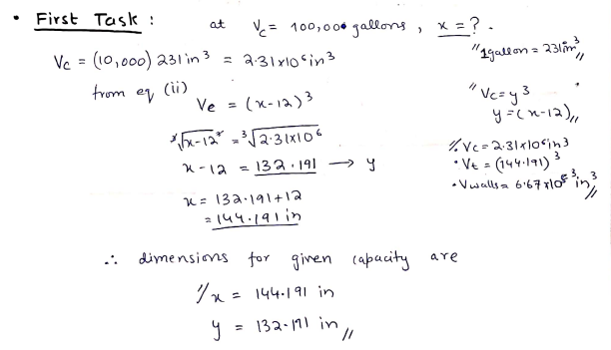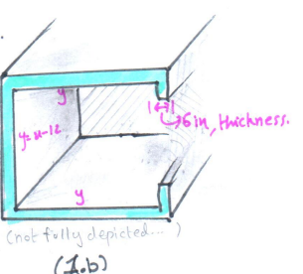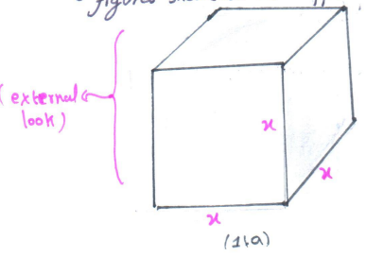 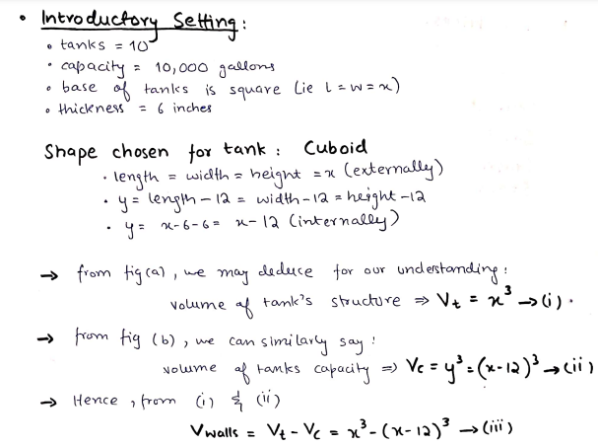

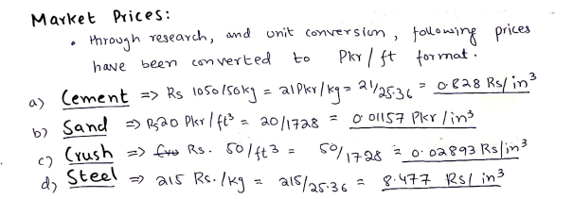

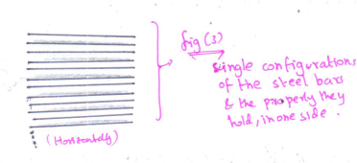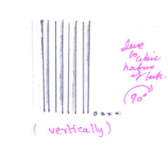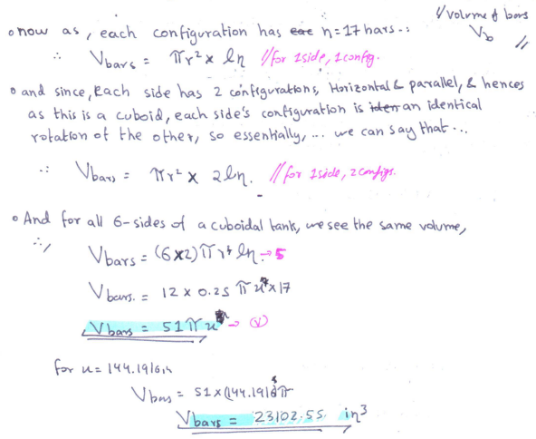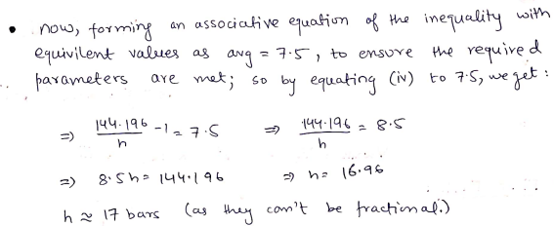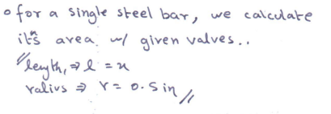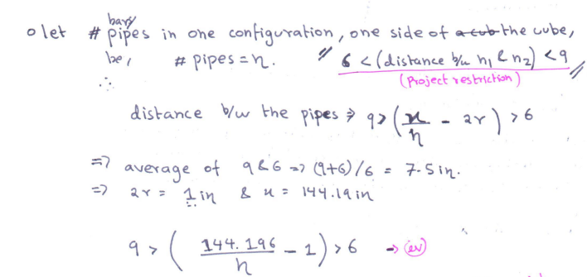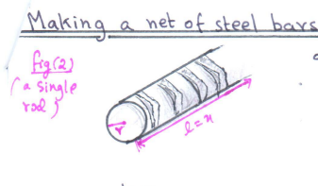

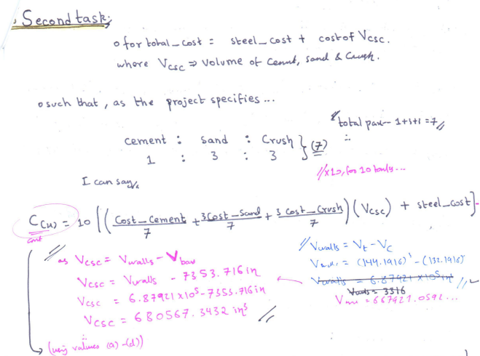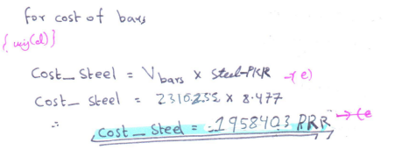

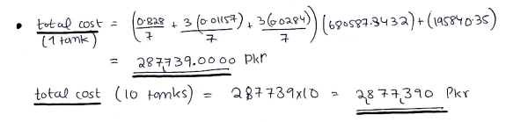

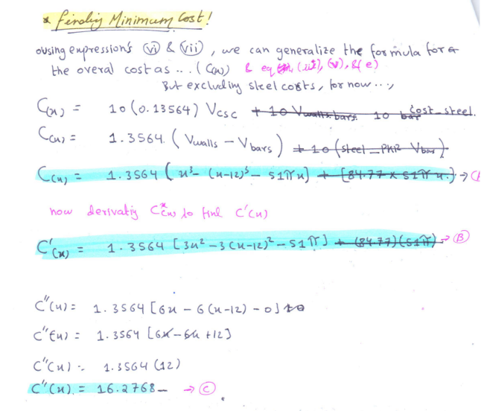

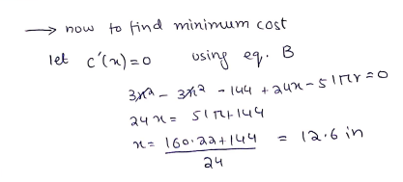

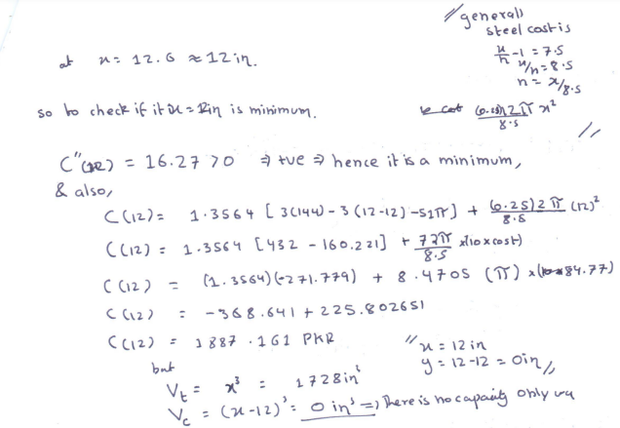

**MATLAB code:** The description of each part of the code is displayed as comments.

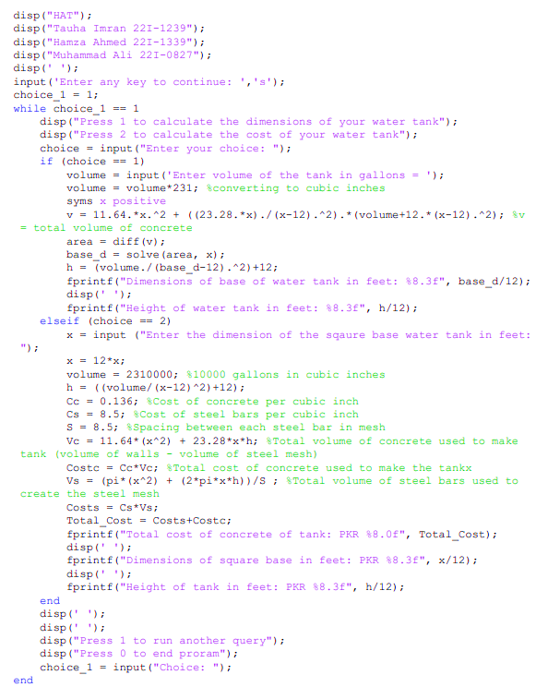

**Tools used (other than usual):**

1. Differentiation: diff(arg1)
2. Solve (arg1, arg2) solves argument 1 for a certain value to find argument 2

**MATLAB Solutions and Results:**

1. **Finding cost using dimensions and then checking them for more than 10 values:**

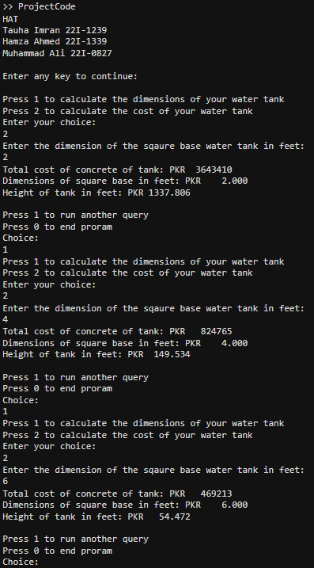In the following results, square base dimensions are input and the cost of water tank has been calculated as output.

In the code on the right, three values: 2, 4, 6 are input and similarly other values can also be input to produce the following results:

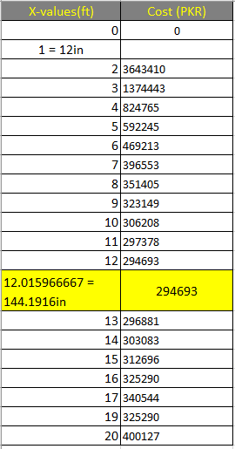

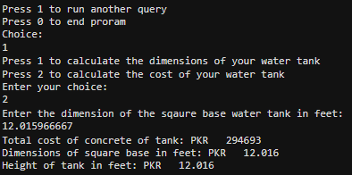On the right is the output when we input the value we had obtained through our calculations above. It is highlighted in the table above in yellow. As the table shows, it is the minimum price.

1. **Finding optimal dimensions for volume input (square base constraint):**

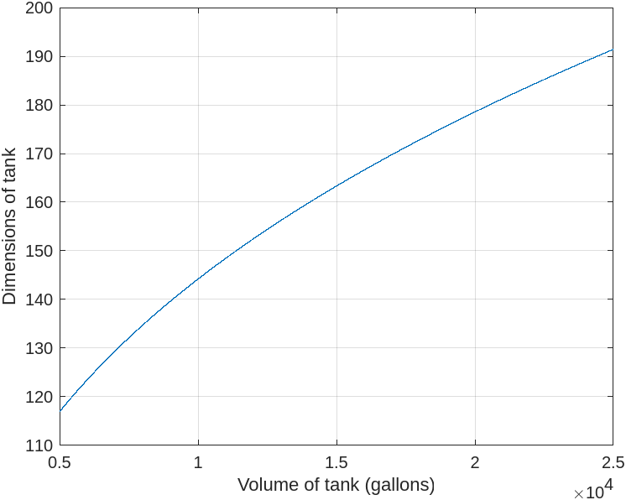Graph given shows how the optimal dimensions vary according to volume input:

As can be seen from the graph, the optimal dimensions for tank of 1x10^4 are almost 144 inches which is in line with our by hand calculations. Other values can also be obtained by using the graph and are displayed in the table bottom right. Also, below displayed are the MATLAB results of our program.

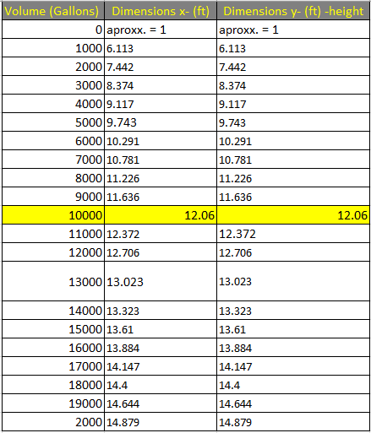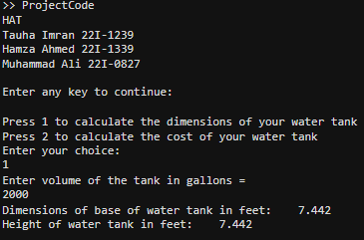

Repeating the same loop:







**Conclusion:**

The presented solution was tackled by taking a cubic shape structure and working with that idea to derive and calculate the values for the dimensions as well as formulate expressions for the different volumes. Then market values were gathered and used to formulate the cost functions with the volumetric functions. After this process we had figured out a calculated cost for 10 cubic water tanks with a capacity of 10,000 gallons each, to be 2,877390 Rs/-. The functions were also analyzed via the use of differentiation in applied optimization to find out the minimum cost and dimensions possible for our tank.

The then formulated functions were generalized and adapted into computational calculations and Analysis. General formulas are then used to provide the user with an idea for the ideal dimension and/or the minimum cost for given volume. These General formulas when plotted give us a continuous graphs making it easy for us to visualize the effect one variable has on the other. The MATLAB software was used to form required functions and plot our graphs, whilst data was assembled in an MS-Excel sheet for further analysis. The findings were discussed in the report.

Overall, the computational and theoretical results showcase similar trends and values reconfirming our solution to the task at hand.

**Contribution:**

Muhammad Ali was responsible to come up with the process needed to be able to complete the task. Step by step processes and their execution, as shown in the flowchart, were needed to ensure the project headed towards a progressive direction as efficiently as possible. Tauha Imran played his part by firstly, drawing a sketch to give the idea a physical view. Then, he did all the by hand calculations, deriving the formulas by hand and solving for dimension, optimum volume and costs etc. He also researched the sources required such as prices from the current market and integrating them into the cost. What was most challenging was the formation of the passage to find a volume construction stripped of all other items, including the steel-bar mesh. The need to recheck continuously was a bit annoying but it was fun to think outside the box. Hamza Ahmed was responsible for making the required programs on MATLAB. He had to research and learn how to use the derivative and quadratic commands using the MATLAB syntax. He also had to learn how to run a step-by-step process and ask for input and display output within the same syntax. It was challenging to align the results from the program with the analytical results, but it was achieved by keeping a keen eye out for any errors and checking for anomalies. Finally, the report was edited and put into order and place by Muhammad Ali. It had to be constantly checked and aligned with the guidelines provided by the Project Statement. Graphs for general functions were also plotted by him to provide an overview.